In this home page I have my personal detail, my photo and at the top of the page have a navigation bar.

In this page I have my self-introduction, learning skills and experience. User also can download my resume at button “Download Resume”. Use can see my education.

In this page user can see my projects what I done before, user also can click the “View Demo” to see code at online compiler.

In this page user can see my information of the left side. User also can send comment or give me their suggestions at the right.

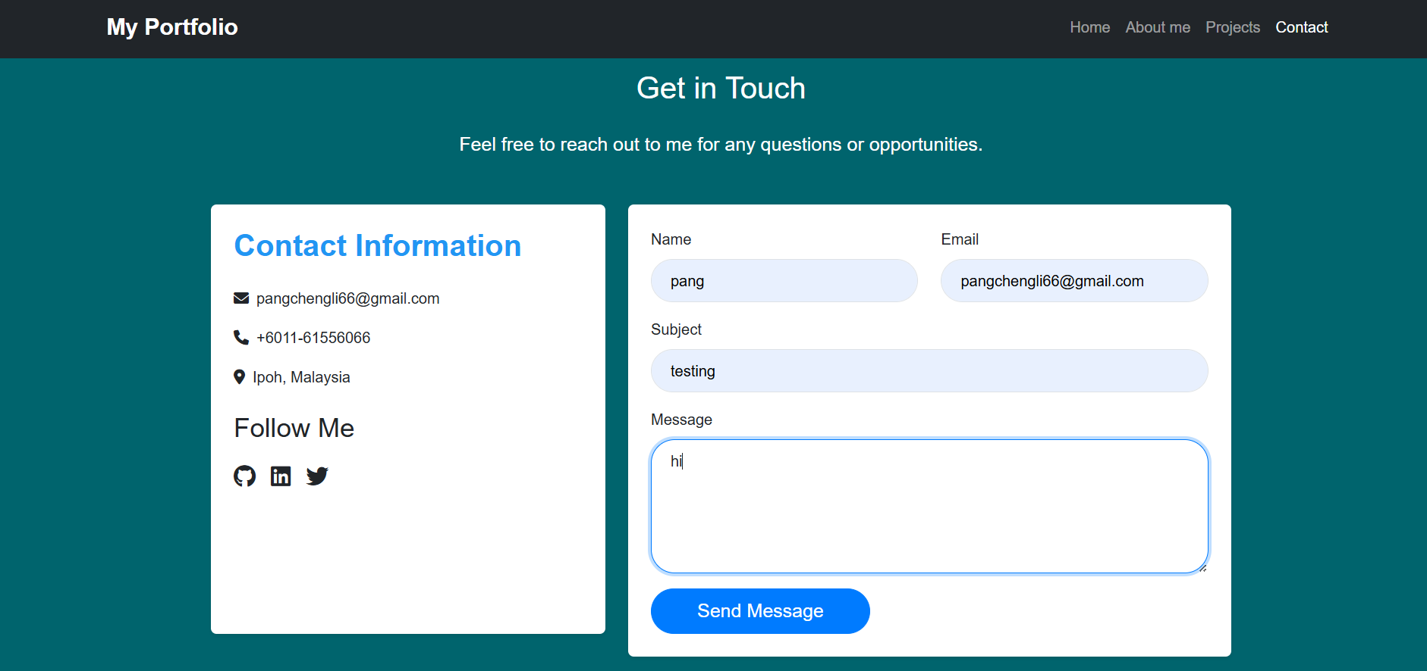

When the user successfully sends the massage it will come out like this.

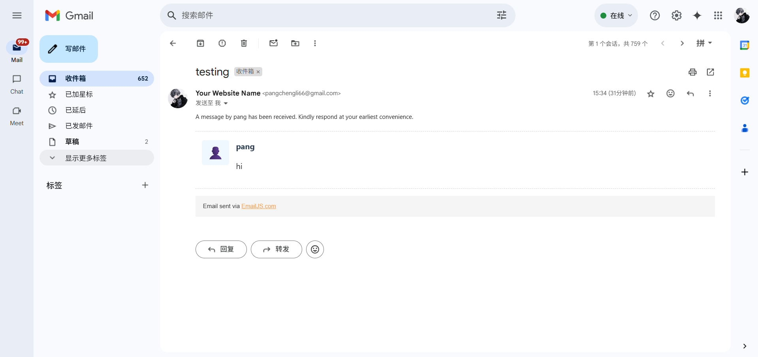

In my email I will receive user comment, I will know who to reply.